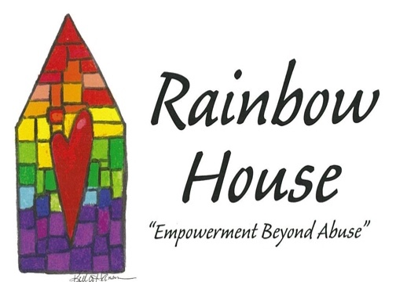
OUR AGENCY MISSION STATEMENT

We believe: No one deserves to be abused be it emotionally, physically, or sexually. Our prime service is the safety and empowerment of all victims and their children.
We Will: Provide prevention, education, and information to our community, families and schools.
Rainbow House Domestic Abuse Services, Inc.
P.O. Box 1172, Marinette, WI 54143 (800) 956-6656
1530 Main St. Marinette, WI 54143 (715) 735-6656 fx: (715) 735-7293
1008-B Pecor St. Oconto, WI 54153 (920) 834-5299 fx: (715) 735-6656
www.TheRainbowHouse.us
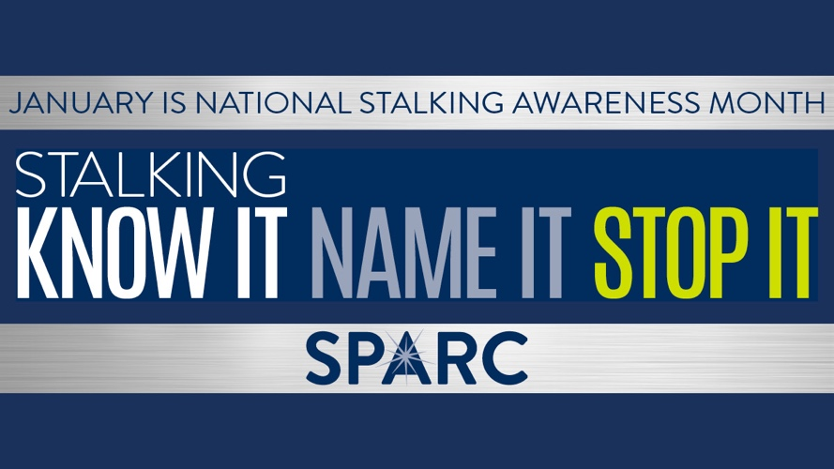
January is National Stalking Awareness Month (NSAM)! Stalking is a prevalent crime that often co-occurs with domestic violence. Stalking is a pattern of behavior directed at a specific person that causes fear.
Stalking can be an extension of power and control in an abusive relationship, and many abusers stalk their partners both during and after the relationship has ended. Intimate partner stalkers are the most dangerous stalkers: they are more likely to approach victims, escalate behaviors, re-offend and assault their victims. Stalking is a terrifying and psychologically harmful crime in its own right as well as a predictor of lethality: in 85% of cases where an intimate partner attempted to murder his partner, stalking preceded the attack.
Though millions of men and women are stalked every year in the United States – with a frequent co-occurrence of domestic violence — the crime of stalking is often misunderstood, minimized and/or ignored.
We all have a role to play in identifying stalking and supporting victims and survivors. Learn more (click here) about stalking and how you can help stop it!

Survivor Support Group Information
Young at Heart Group
(Senior Domestic Violence Support Group)
60 years of age & over
Held: Every Tuesday from 1:30pm – 3:00pm
Where: Rainbow House 1530 Main St. Marinette
Support Group
(Open to all victims and survivors)
Held: Every Thursday from 10:00am-11:00am
Where: Rainbow House 1530 Main St. Marinette

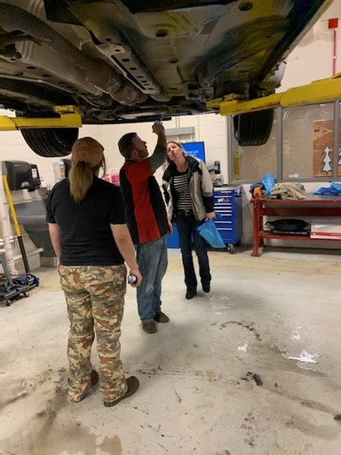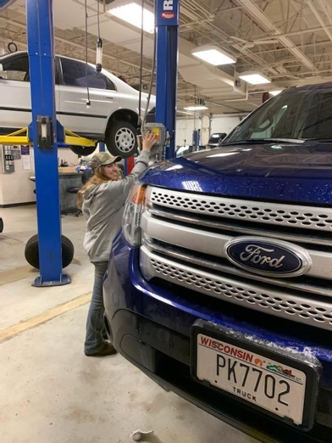
NWTC offers Car Care Class for Survivors
NWTC Automotive Department shared their time and talents with domestic abuse survivors. Survivors were taught basic automobile terminology and were given the opportunity to spend time in the shop. Checking fluids and tire pressures where some items covered.

Under Construction…
We are adding on to provide more space and services for men, women and children. With the help of local contractors, the Rainbow House in Marinette is adding a third floor. This new space will allow clients access to exercise equipment, yoga classes, and a meeting space for group and activities. Completion of project is set for
mid - January. Thank you to WHEDA, the Little Rapids Corporation – Egan Family Foundation, Department of Children and Families, Flagstar Bank, & Stephenson National Bank for their contributions towards this project.
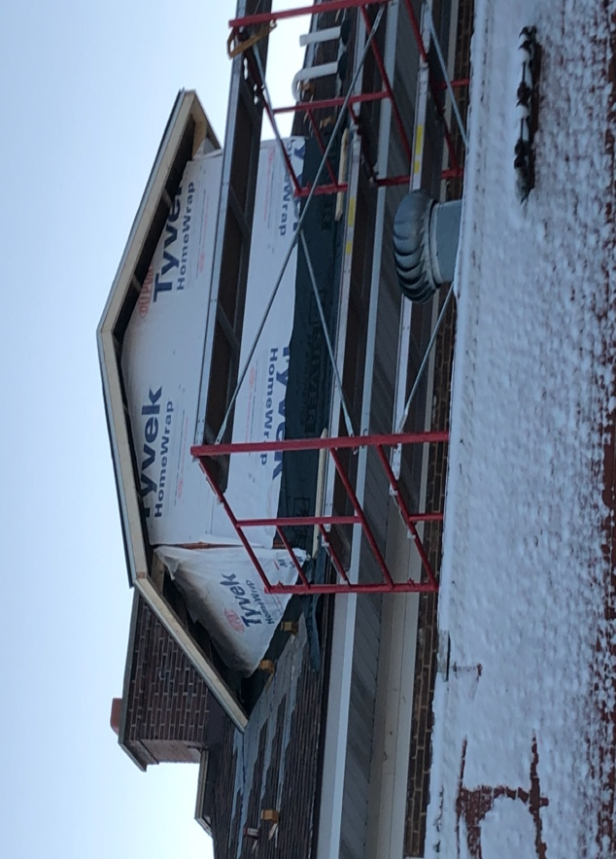
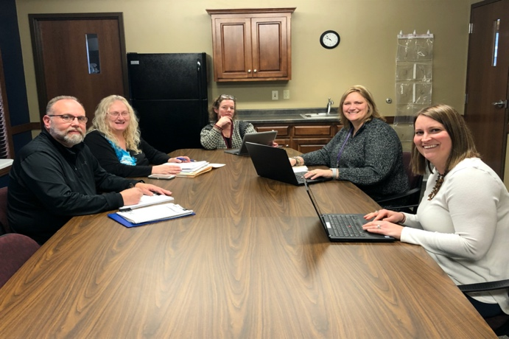
Domestic Violence High Risk Teams of Oconto and Marinette Co. meeting for 1 year in January
Pictured in photo to the left are members of the Oconto High Risk – Marissa, Oconto Probation & Parole; Jessica, Rainbow House; Courtney, ED, Rainbow House; Barbara, Victim Witness; and Keith, Oconto Sheriff Office.
Oconto and Marinette teams meet on a monthly basis to review Lethality Assessment Protocols (LAP) that are conducted from Law Enforcement at the scene of Domestic Violence.
Pictured in photo to the right are members of the Marinette High Risk- Joette, Rainbow House; Courtney, ED, Rainbow House; Mary, Victim Witness; Jessica, Rainbow House; Dawn, Probation & Parole; missing from photo Craig, Marinette Sheriff Office and Tom, Marinette Police Department
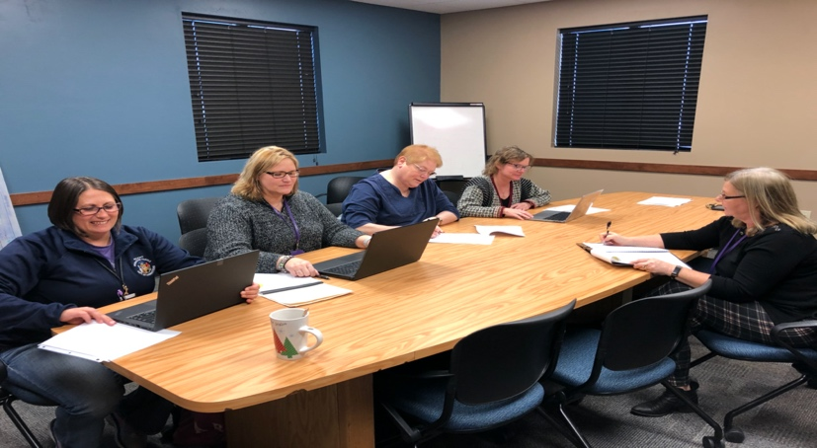

*Gift Cards: Walmart, Amazon, and Menard’s
* Cooking utensils * Ground Coffee
*Pots and Pans *Garbage bags (Tall Kitchen size)
* * Pocket size 2020 calendars
Shopping on On-Line for the Rainbow House
Find our wish list online now at: Amazon
Agency Staff Good Read Book Recommendation

VOLUNTEERS NEEDED
Rainbow House is looking for volunteer help. We need help moving clients and with shelter projects. Volunteers are needed for childcare as well for when clients have appointments away from shelter. We gladly accept adults as well as teens! Training is provided.
http://therainbowhouse.us/volunteer-application/

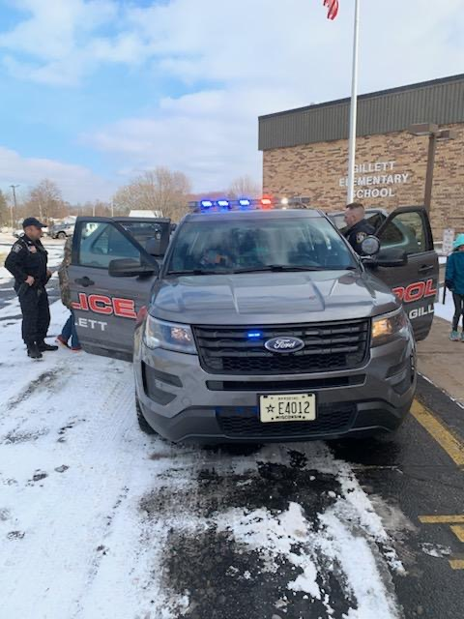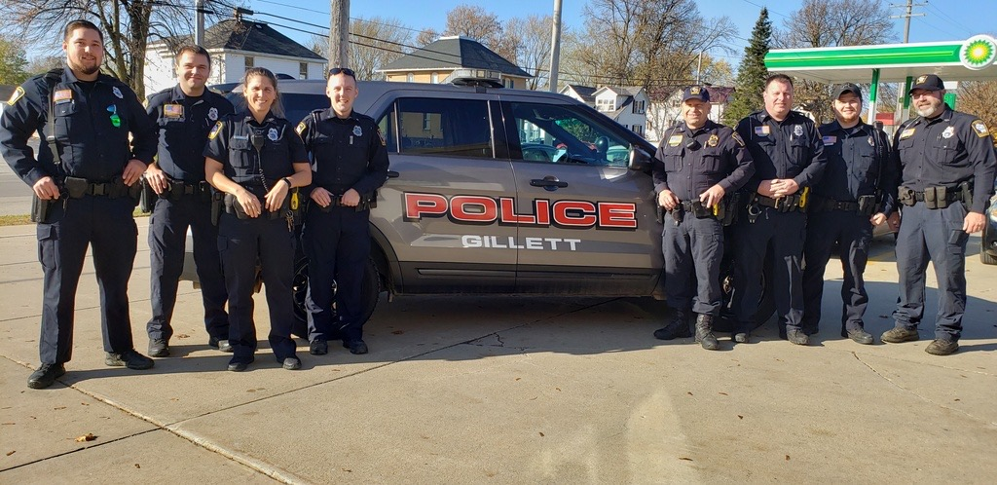
Agency School Presentations
Time was spent in the city of Gillett, where agency staff presented to 2nd – 5th grade students on Domestic Violence 101- healthy friendships and digital dangers.
Police Department Training
Advocates from the Rainbow House where invited to provide a training at Gillett Police Department. The training consisted of Domestic Violence 101, agency services and the Lethality Assessment Protocol.
Development and Implementation of Domestic Violence
High Risk Teams in Rural Communities
Courtney Olson, Executive Director, Rainbow House Domestic Abuse Services, Marinette, WI,
Jessica Honish, Lead Advocate, Rainbow House Domestic Abuse Services, Marinette, WI

When evaluating domestic violence lethality, research demonstrates that location matters. For example, rural women endure more severe violence and experience a higher risk of lethality. Delayed law enforcement response times, coupled with greater distances to life-saving medical intervention, increases the risk of fatality. Domestic Violence High Risk Teams are essential in rural areas as a result, yet few communities have them in place. Courtney and Jessica will present at the International conference on how to successfully develop and implement domestic violence high-risk teams in rural communities.

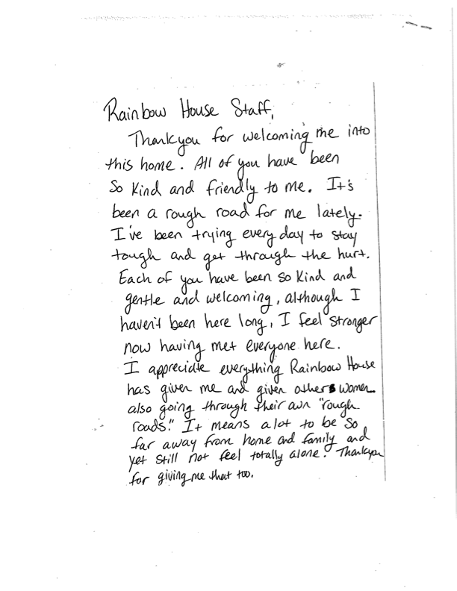

How Can you Help us Help Others?
I/We would like to advise you that I/We have made a provision for a gift to Rainbow House Domestic Abuse Services, Inc.
Name(s) ______________________________________
Address ______________________________ State ________ Zip ___________
Phone _____________ E-mail(s) _______________________________
I/We have made the following provision for a gift:
□Cash Gift (Make check payable to Rainbow House) Enclosed is my check
My pledge will be paid in equal amounts of _______over a period of _____ months/years
□Bequest/Will/Revocable Trust □IRA or other Retirement Plan beneficiary designation □Life Insurance beneficiary designation □Charitable Remainder Trust □Pooled Income Fund □Charitable Gift Annuity □Real Estate
□Other: _________________________________
The estimated amount of this gift is (optional) ______________
A copy of the legal document that establishes this gift:
□Is enclosed □Was provided to Rainbow House □Will not be provided
Recognition of support:
I/We authorize Rainbow House to list me/us in the Honor Roll of Donors. Our/my name(s) should appear as: ________________________________________________________________________ I/We prefer confidentially and do not wish my/our name(s) to be listed, but would appreciate receiving on-going information and invitation for
Rainbow House events.
My Employer has a Matching Gift Program
Employer: ______________________________ Gift Amount:__________
Signature________________________________________ (this Statement of Intent is non-binding)

