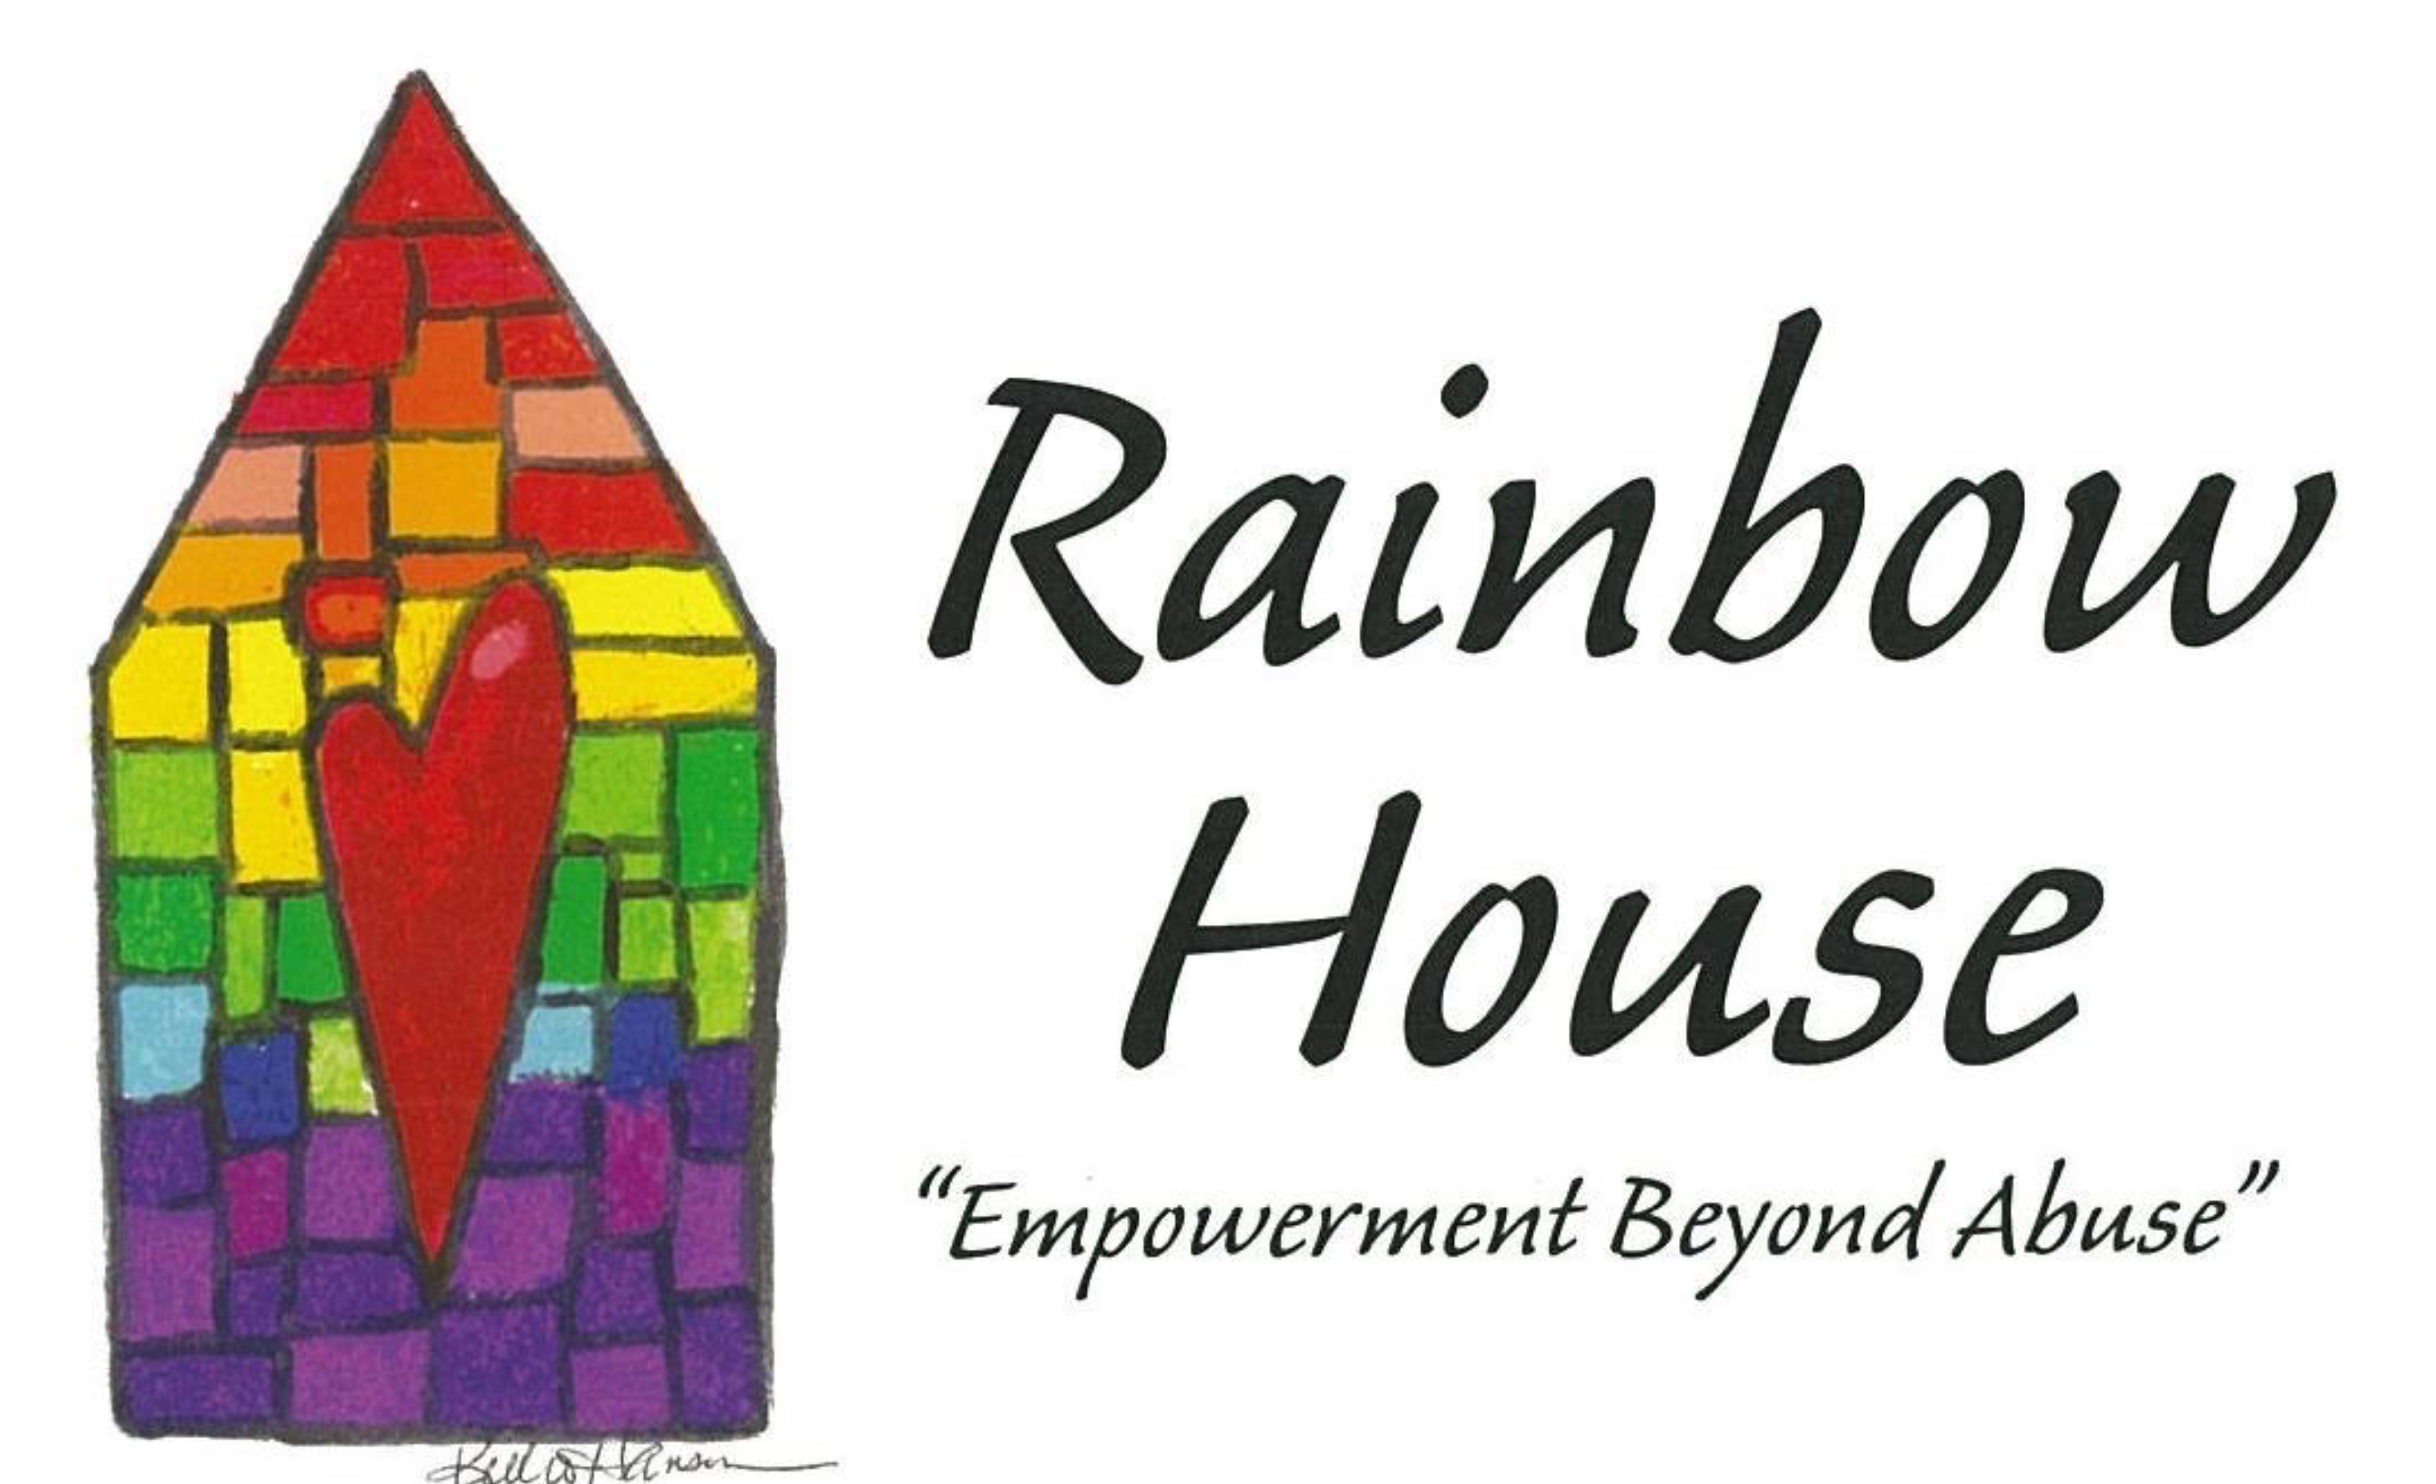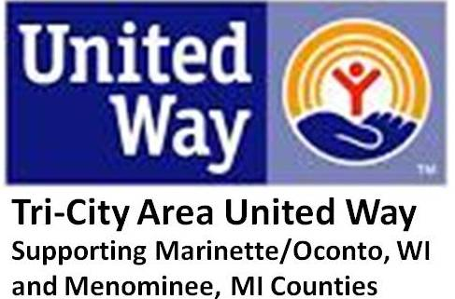

**"I SAID YES"***--(Author Unknown)*  
I said "Yes" again  
And I couldn't believe my ears.  
Yep, I said "Yes" again.  
I'm one of the chronic volunteers.  
  
They asked me for my help  
And I thought, who has the time?  
The phone calls and those meetings  
Just for the fun and not a dime.  
  
So I thought it over,  
Do I want to give or take?  
I enjoy it all so very much  
The decision was easy to make.  
  
I've loved every single minute  
Of working with the gals  
Even when the hour was late  
It was always for my pals.  
  
So please don't try to tell me  
Volunteering is a pain.  
'Cause for all the friends I've made  
and all I've learned,   
I'll say "Yes, Yes, Yes" again and again!

* Crisis line Response
* Client Mentoring (employment skills, financial literacy)
* Childcare/ Activities
* Client relocation Assistance
* Client Transport
* Community Events/Awareness
* Donation Organization
* Garden, Snow
* Shelter Maintenance
* Volunteer Advocacy

Call ***Rainbow House*** and see if we are the right match for you!!

715-735-6656 or

1-800-956-6656

Is in need of a Few Good Men and Women to Volunteer

1. Volunteers live longer and are healthier.
2. Volunteering establishes strong relationships
3. Volunteering is good for your career.
4. Volunteering is good for society.
5. Volunteering gives you sense of purpose.

www.therainbowhouse.us

 

Rainbow House Domestic Abuse Services Inc Mission Statement

WE BELIEVE: No one deserves to be abused, be it emotionally, physically, or sexually

Our prime service is SAFETY AND EMPOWERMENT OF ALL VICTIMS AND THEIR CHILDREN.

WE WILL: Provide prevention, education, and information to communities, families and schools.

Why Volunteer you ask.

Volunteering offers vital help to people in need, worthwhile causes, and the community, but the benefits can be even greater for you, the volunteer. You are out in the community making new friends and contacts. It increases your social and relationship skills.

You are not just moving boxes, answering a phone line, providing transport or organizing a donation. You are involved in most importantly, fighting domestic violence. You are helping to save victims and children. You are helping our mission in putting an end to domestic violence.

## What’s in it for me?